

**SE3523 -Web Engineering**

**Project Report**

**“Mehfil: Event Booking Website”**

**Submitted by:**

* **Javeria Khalid BSE221001**
* **Malik Hamza Nawaz BSE221044**

**Submitted to: Dr Muhammad Furqan**

**Dated: January 12th, 2025**

Table of Contents

**Chapter 1: Introduction** 3

**1.1.** **Overview of the Entire Project** 3

**1.2. Introduction** 3

**1.3. Objectives** 3

**1.4. Significance** 4

**Chapter 2: Problem Statement and Solution** 4

**2.1. Problem Statement** 4

**2.2. Solution** 4

**Chapter 3: System Implementation** 5

**3.1. Implementation** 5

**3.1.1. Front-End** 5

**3.1.2. Back-End** 11

**3.1.3. Database** 13

**3.2. Scenarios** 16

**3.2.1. Message Form in ‘contact.html’** 16

**3.2.2. Event Booking Form in ‘booking.html’** 18

**Chapter 4: Conclusion** 19

**4.1. Conclusion** 19

**4.1.1. Key Findings and Outcomes** 19

**4.1.2. Impact** 19

**4.1.3. Recommendations or Future Improvements** 20

# **Chapter 1: Introduction**

## **Overview of the Entire Project**

The **Mehfil** event-booking website is a comprehensive platform designed to allow users to seamlessly explore services, view galleries, inquire through a contact form, and book events. Targeted primarily at individuals and event planners, Mehfil offers a one-stop digital solution for discovering event venue options, reviewing menus and packages, and submitting event bookings. By utilizing modern web development practices and a robust backend, Mehfil provides a dynamic and user-friendly experience, ensuring that event planning becomes an easy and streamlined process.

## **1.2. Introduction**

The Mehfil website is a custom-built web application designed for event booking and client communication. It enables users to explore the venue's gallery, services, and menu, while also allowing them to get in touch with the venue's team via a contact form or directly book events through a booking page. With a combination of a polished front-end interface and a powerful back-end system, the platform provides an efficient and interactive user experience. The backend is responsible for handling all data interactions and form submissions, while the front-end ensures that users can easily navigate through the website and submit their event booking requests.

## **1.3. Objectives**

The main objectives of the Mehfil project are:

1. **User Experience**: To provide a visually appealing, easy-to-navigate, and responsive platform for event bookings.
2. **Streamlined Communication**: To enable efficient communication between users and the event venue via the Contact Us form.
3. **Booking Management**: To facilitate a user-friendly booking process where event organizers can submit details and make reservations.
4. **Data Handling**: To securely store all booking and contact information in a structured database.
5. **Automation**: To implement automatic form reset after submission for a smoother user experience.

## **1.4. Significance**

Mehfil addresses the growing demand for online event booking systems by combining modern web development practices with user-centered design. As events and gatherings become more frequent, the need for a central platform where users can explore services and book events is essential. The website reduces the friction in event booking and inquiry processes, streamlining the way people plan their events. Mehfil also strengthens communication between the client and the service provider, enabling personalized interactions, which ultimately improves customer satisfaction and business success.

# **Chapter 2: Problem Statement and Solution**

## **2.1. Problem Statement**

In the event management industry, clients often struggle with the traditional means of finding, booking, and inquiring about event services. Venue managers often face challenges in keeping track of multiple event requests and managing client communication. Additionally, the booking process is often tedious and not streamlined, which creates inefficiencies for both clients and service providers. Without a digital platform, the process is prone to errors, delays, and confusion.

## **2.2. Solution**

The Mehfil website provides a digital solution to these problems by offering a fully integrated event booking system. The website allows users to easily browse through the gallery, review services and menu options, send inquiries through the Contact Us form, and book events directly. Through the use of a well-organized database and user-friendly forms, the system automates several manual processes, ensuring faster responses and accurate data management. For example, users can fill out booking information on the event page, and the system securely stores this data in a database. Once the form is submitted, the details are sent to the venue for processing, and users are immediately notified. By streamlining the entire booking and inquiry process, Mehfil addresses the need for a more efficient and reliable event management platform.

# **Chapter 3: System Implementation**

## **3.1. Implementation**

The implementation of the Mehfil website involves three key components: the front-end, back-end, and database. Each of these components works in tandem to provide an optimized and smooth experience for users, while ensuring the system's robustness and security. This chapter will explain how each of these components contributes to the overall system functionality.

### **3.1.1. Front-End**

The front-end of Mehfil is developed using several web technologies, including **HTML**, **CSS**, **JavaScript**, **Bootstrap**, **jQuery**, and **AngularJS**. These technologies collaborate to create a responsive, modern, and interactive website that provides an excellent user experience.

* **HTML**: Forms the structural foundation of the website by organizing content like text, images, buttons, and form fields in a clean layout.
* **CSS**: Used to style and customize the visual appearance of the website. This ensures that all elements are aligned with the theme and brand identity. CSS also makes the website mobile-responsive, allowing it to adapt to different screen sizes and devices.
* **Bootstrap**: This popular front-end framework is utilized to enhance the website's responsiveness and aesthetics. It simplifies layout design with its grid system, pre-styled components (buttons, forms, modals), and responsive classes. Bootstrap ensures that the Mehfil website is accessible on various devices, from desktops to mobile phones, with minimal custom CSS.
* **jQuery**: A fast and lightweight JavaScript library, jQuery simplifies DOM manipulation, event handling, and AJAX requests. It plays a key role in providing interactive elements like form validation, dynamic content updates, and animations (e.g., form submission feedback, page transitions).
* **AngularJS**: AngularJS is employed to manage the dynamic parts of the website, such as the handling of user interactions, form submission, and providing a single-page application-like experience. AngularJS is especially useful in ensuring the seamless transition between pages and offering users an efficient browsing experience without full page reloads.

Together, these technologies ensure that the Mehfil website is both visually appealing and functionally efficient, enhancing the user experience and ensuring smooth navigation.

#### **3.1.1.1. Home Page (frontpage.html)**

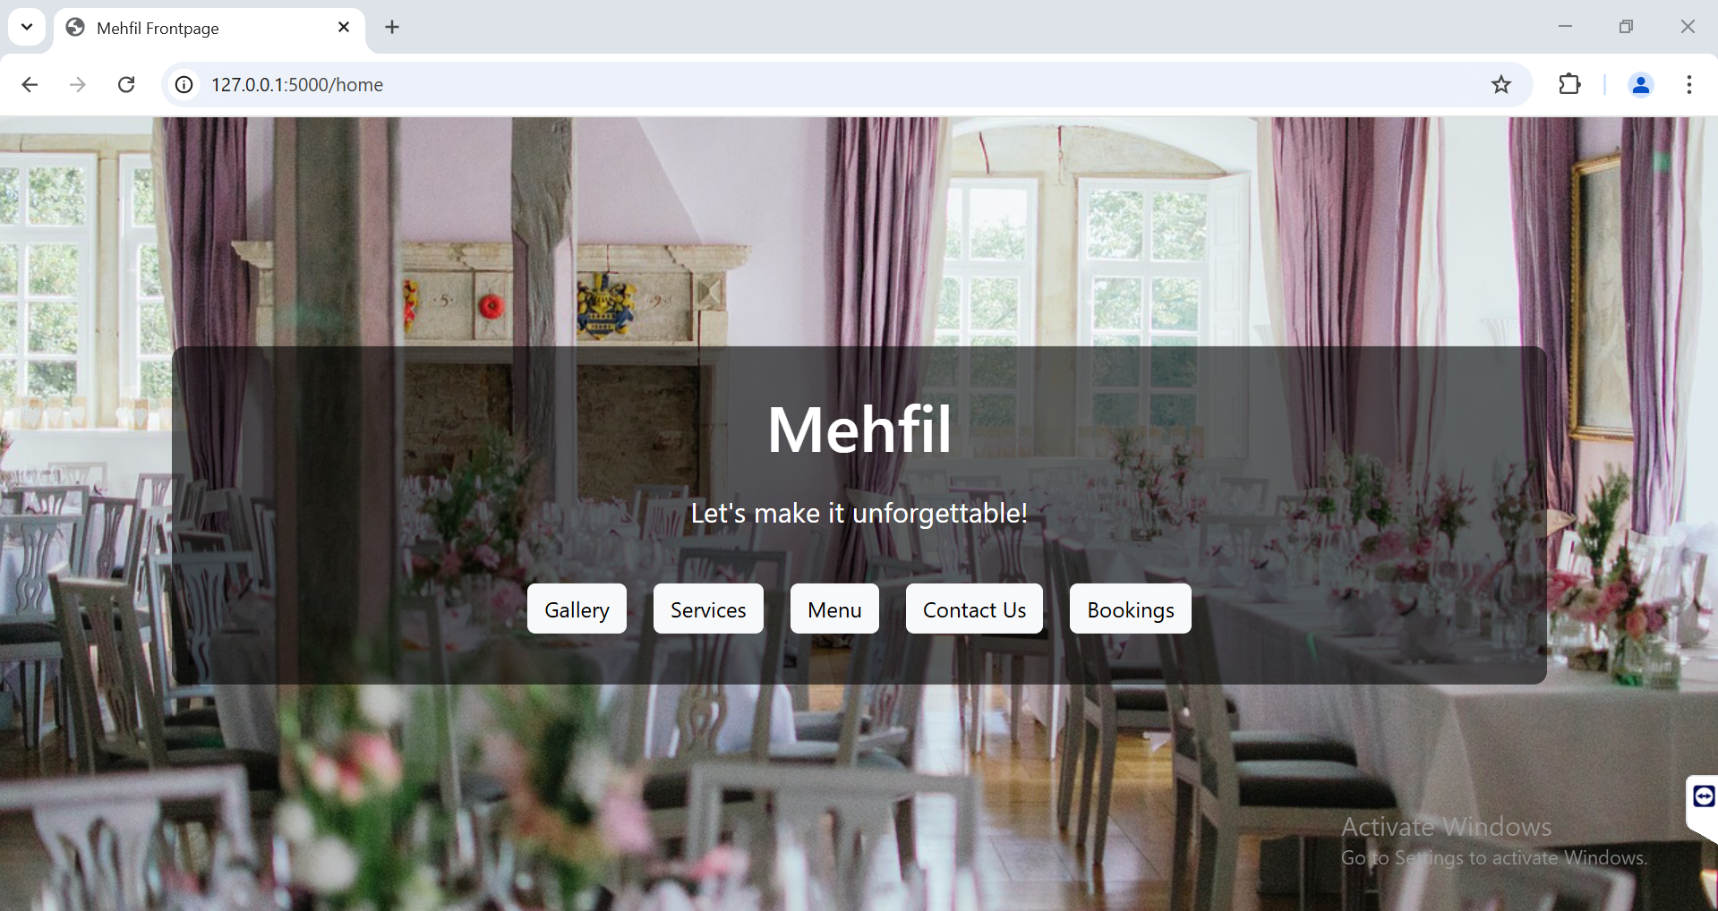

#### **3.1.1.2. Gallery Page (gallery.html)**

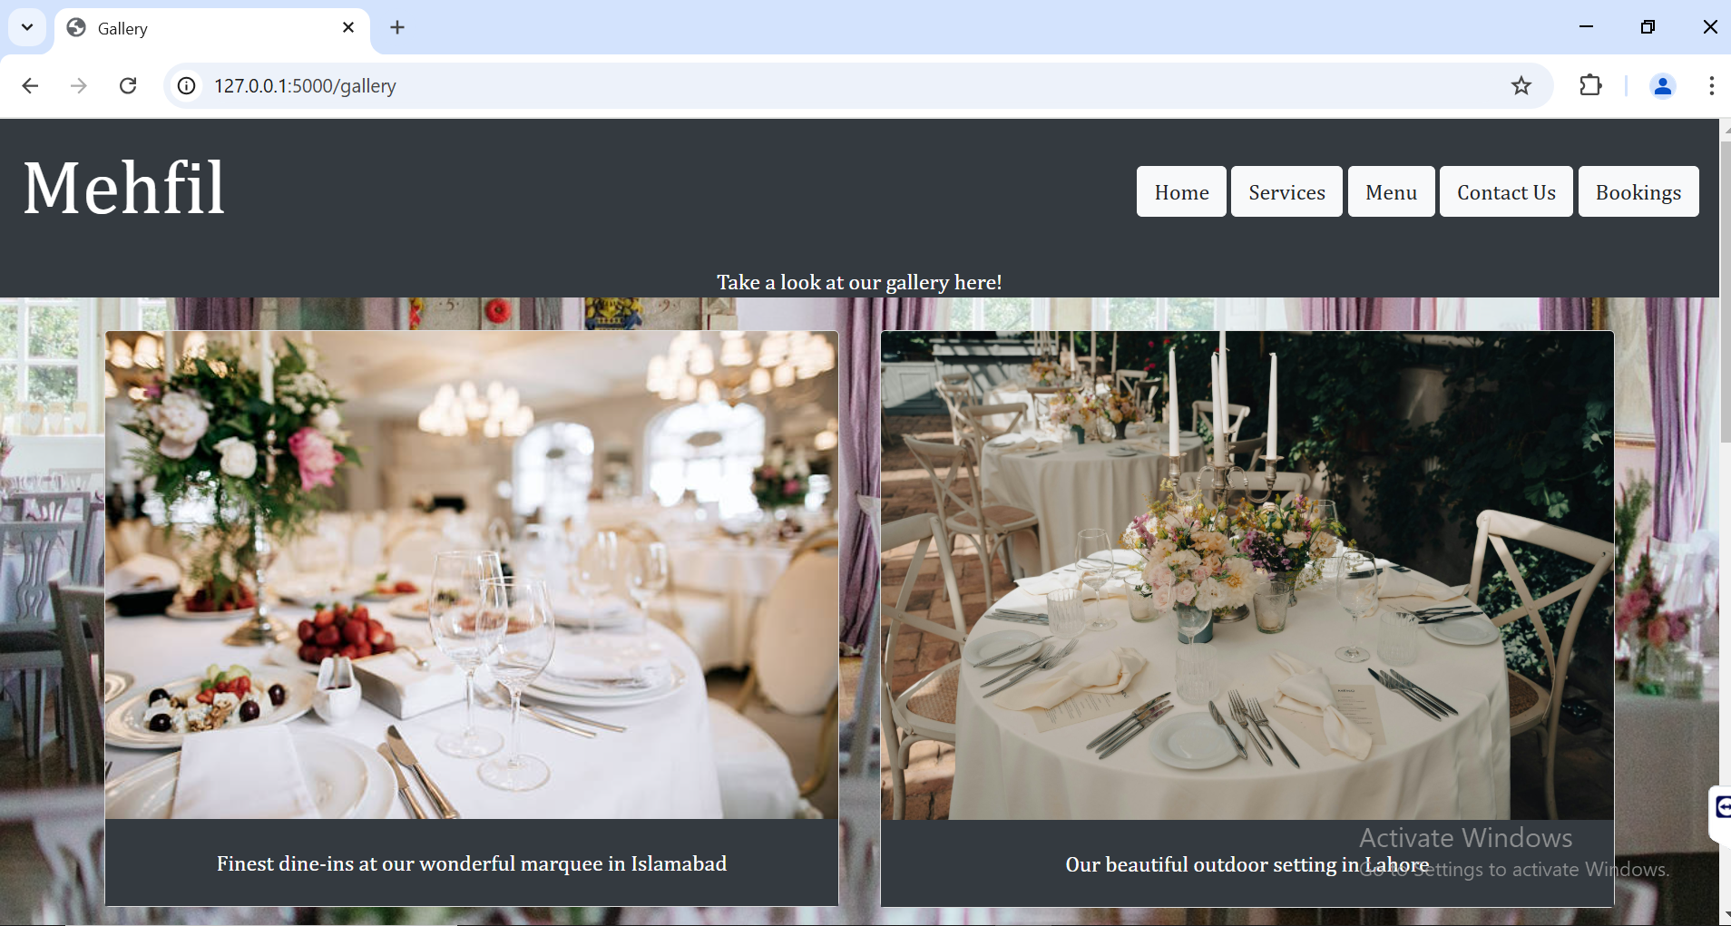

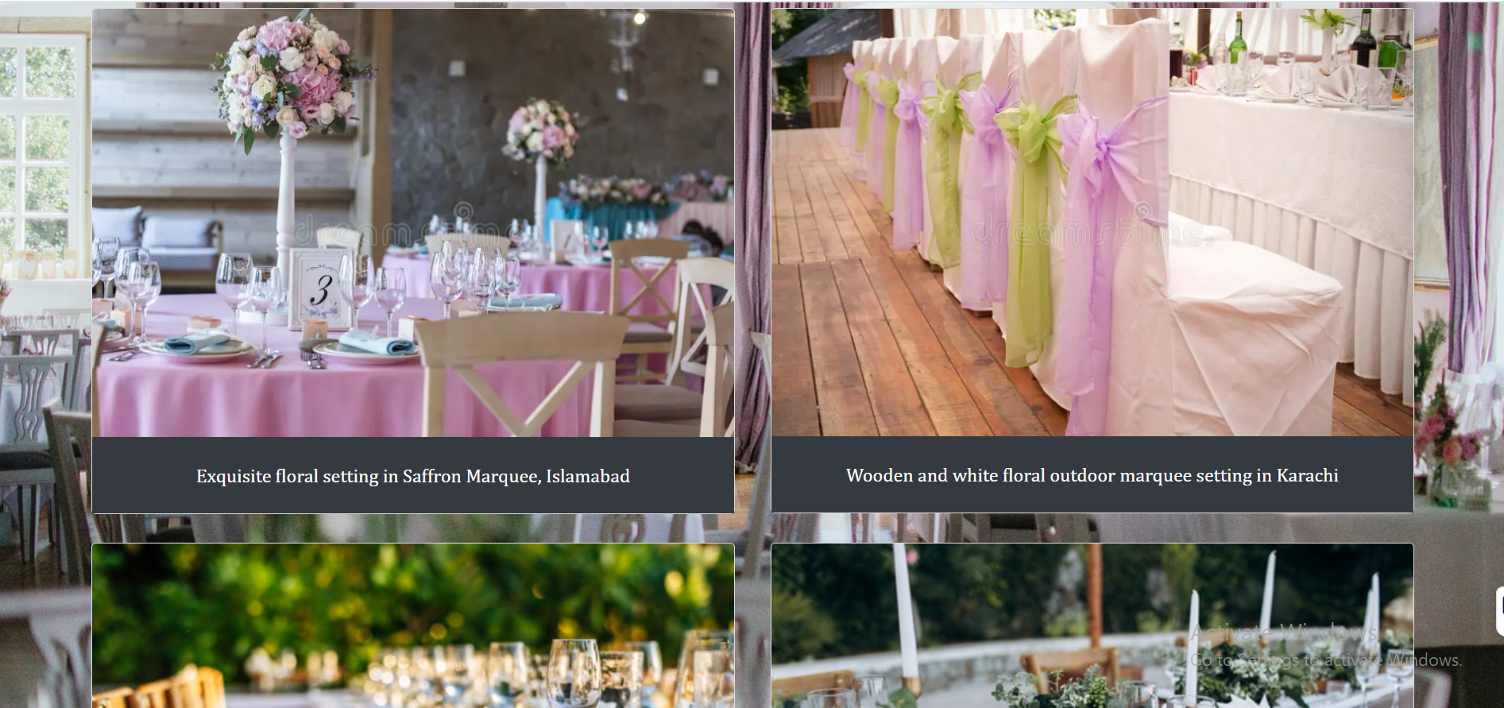

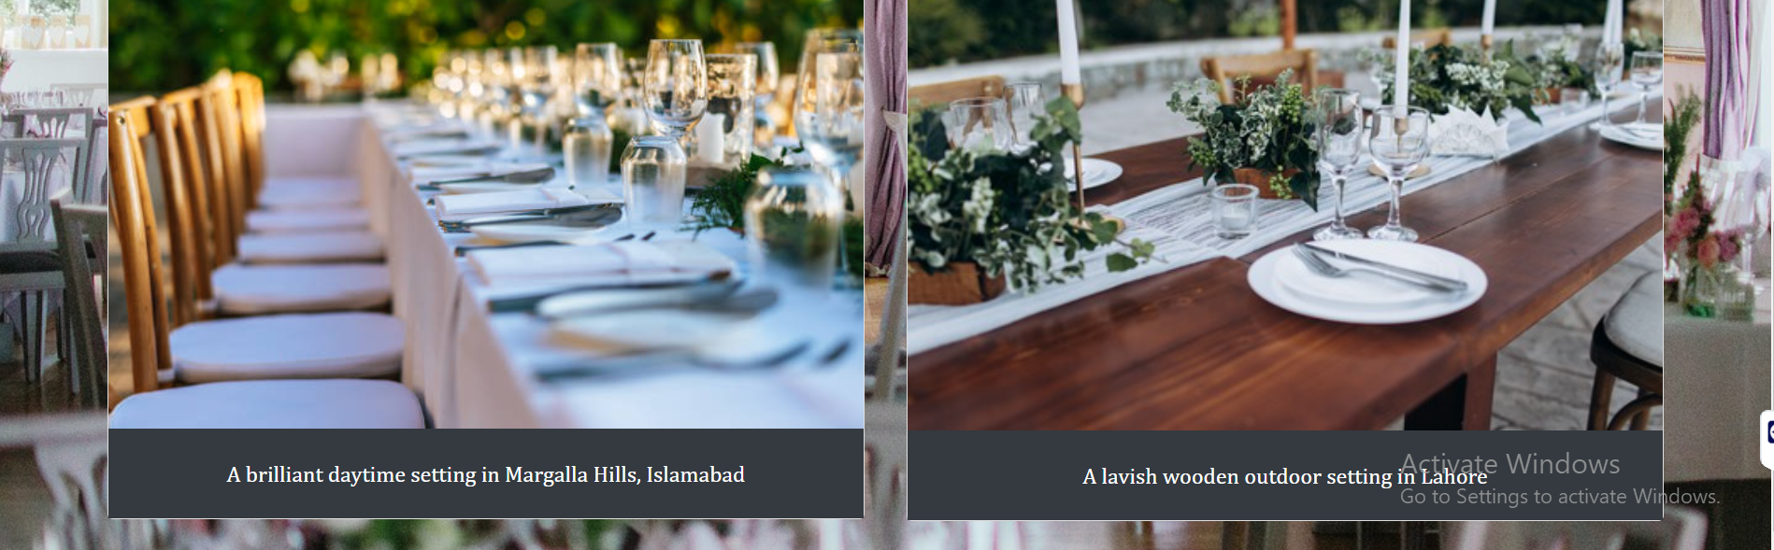

#### **3.1.1.3. Services Page (services.html)**

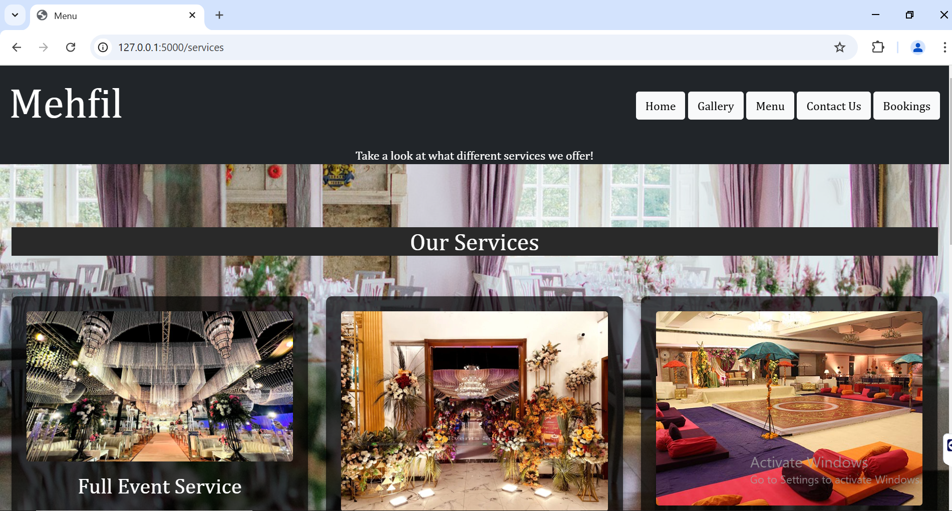

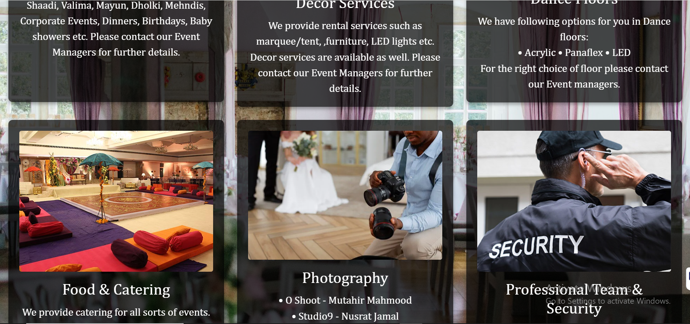

#### **3.1.1.4. Menu Page (menu.html)**

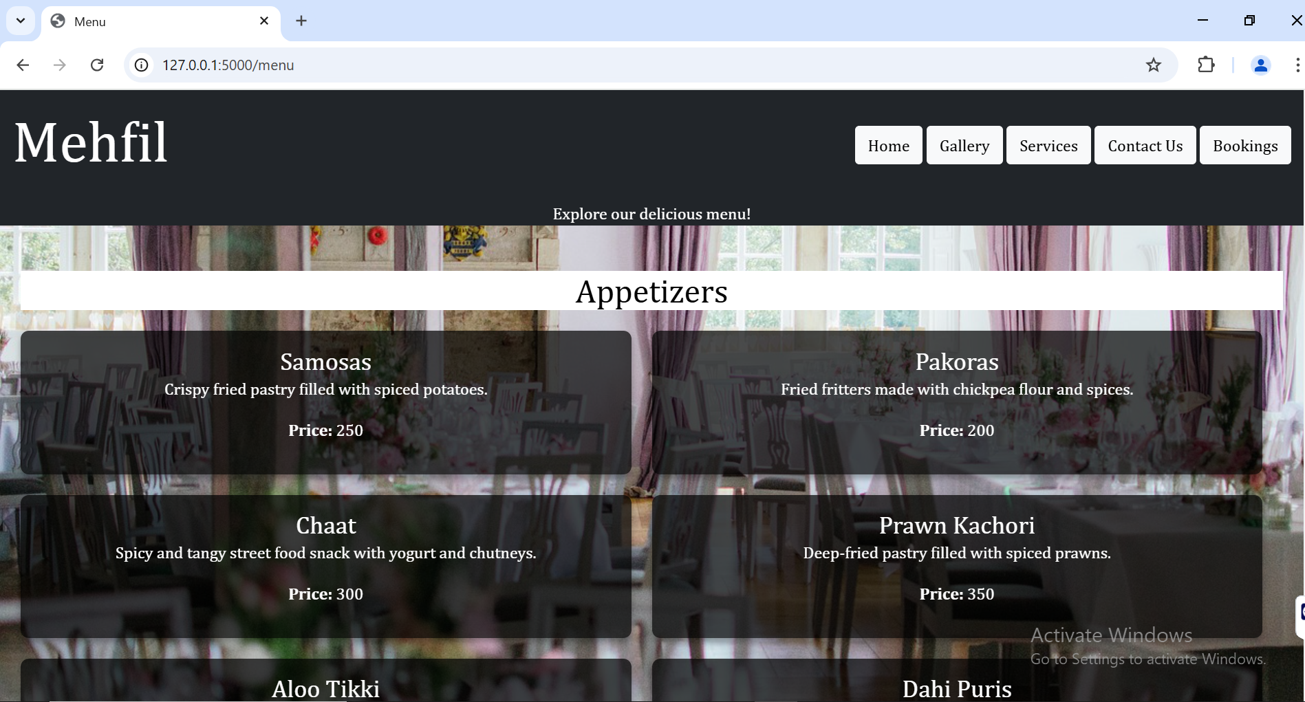

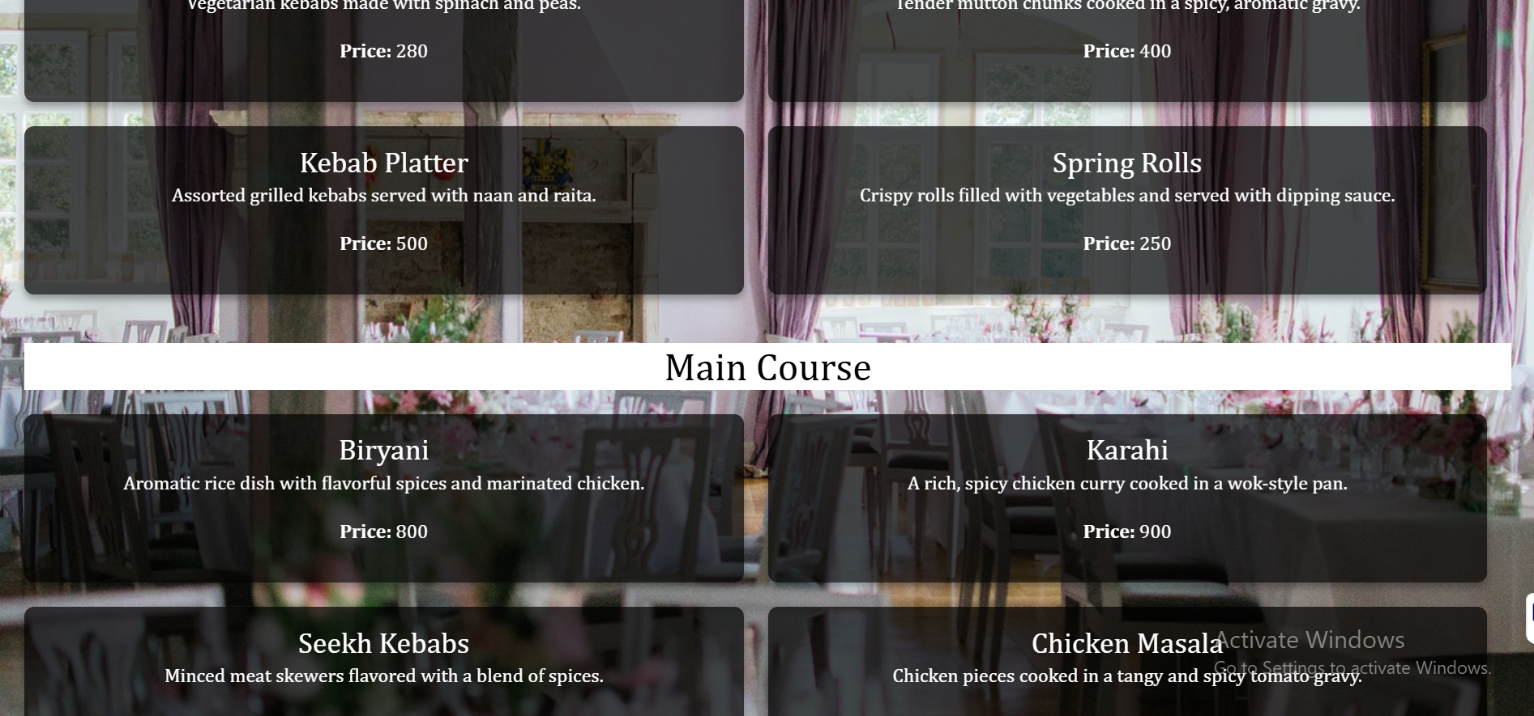

.

.

.

#### **3.1.1.5. Contact Page (contact.html)**

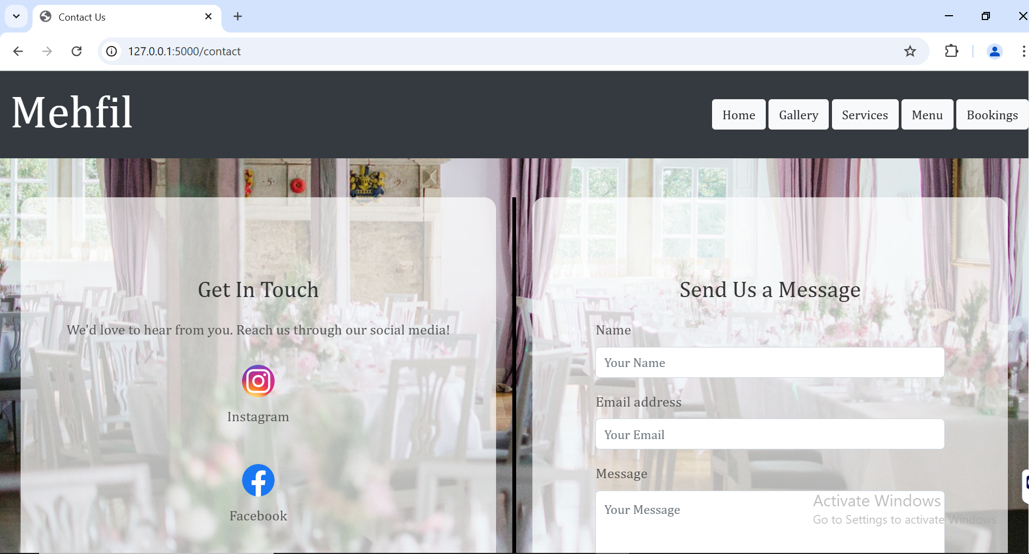

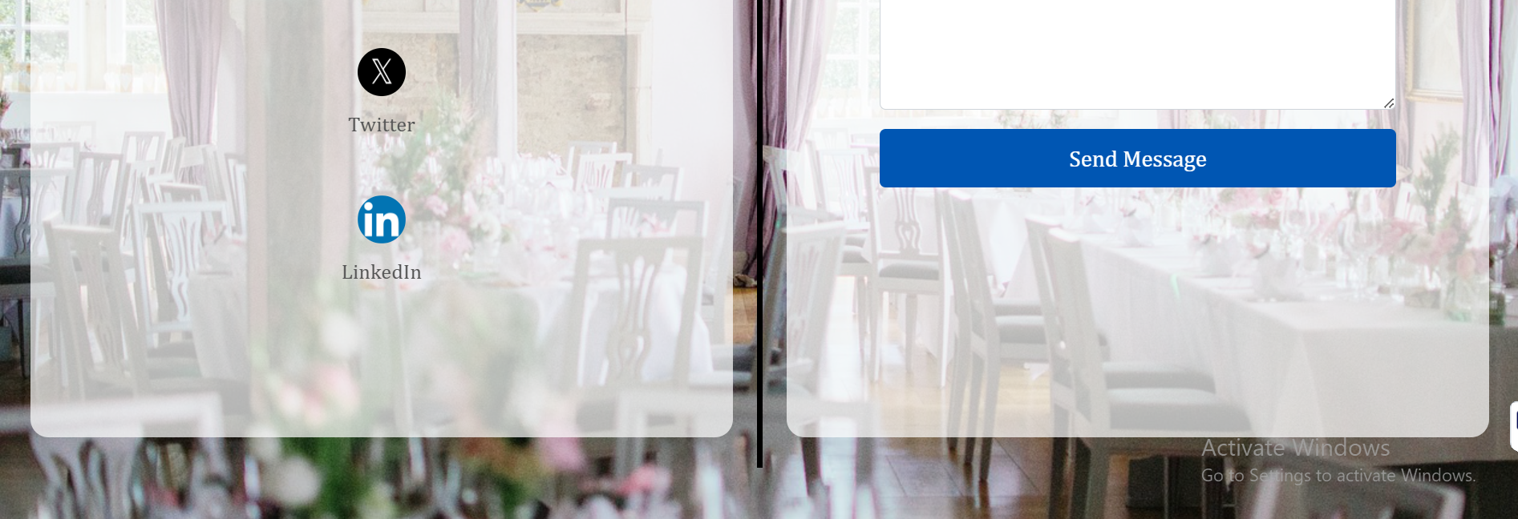

#### **3.1.1.6. Booking Page (booking.html)**

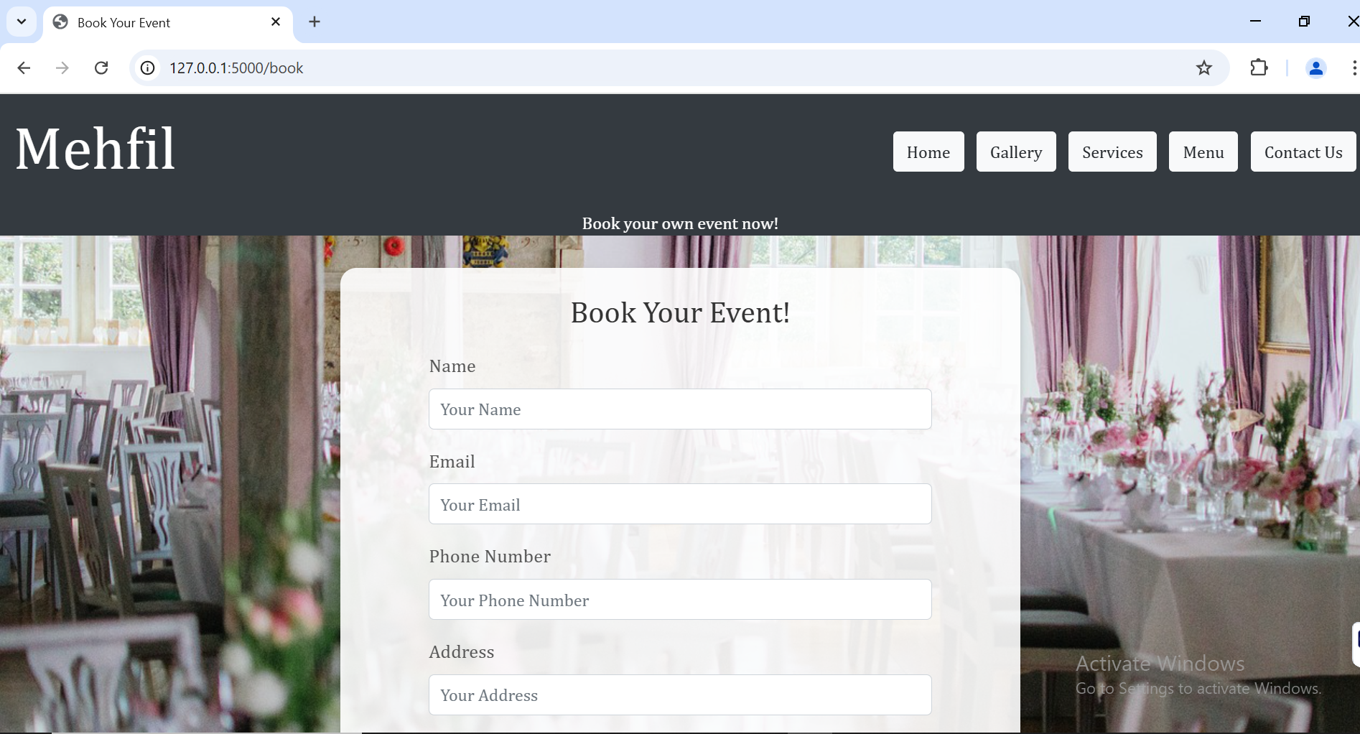

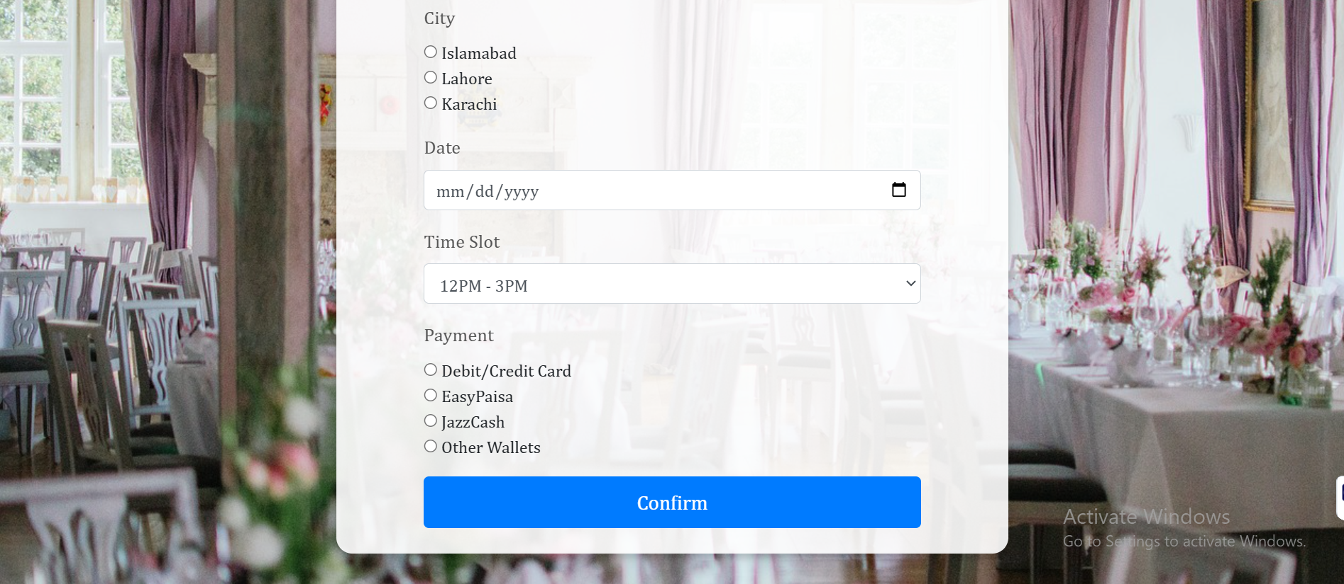

### **3.1.2. Back-End**

The back-end of the Mehfil website is built using **Python** and **Flask**, which provides a lightweight yet powerful web framework for building dynamic web applications. Flask is ideal for handling the routing, form submissions, and integration of the front-end with the database.

When users submit their forms (either contact or booking), the Flask backend processes the data. The backend ensures that the submitted data is validated and then stored securely in a **MySQL** database. Flask's simplicity and flexibility allow for easy handling of form data, user sessions, and error handling, making it an efficient backend solution.

Additionally, Flask facilitates the integration of necessary features such as email notifications to users after successful bookings, providing real-time feedback and keeping users informed about their submission status.

#### **3.1.2.1. Command Prompt**

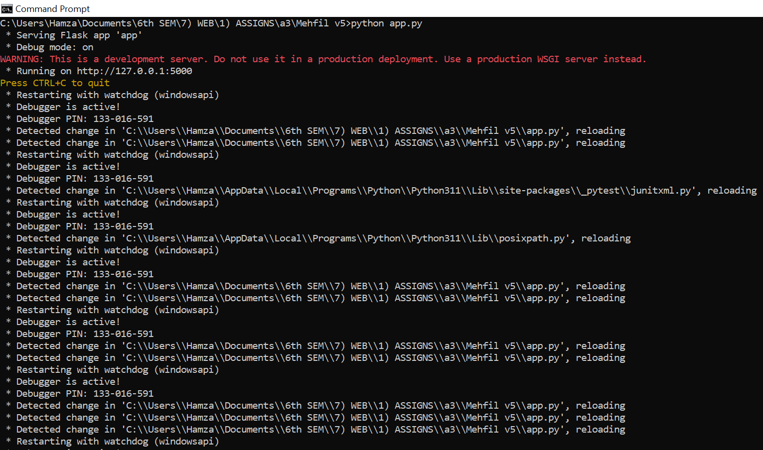

#### **3.1.2.2. VSCode Terminal**

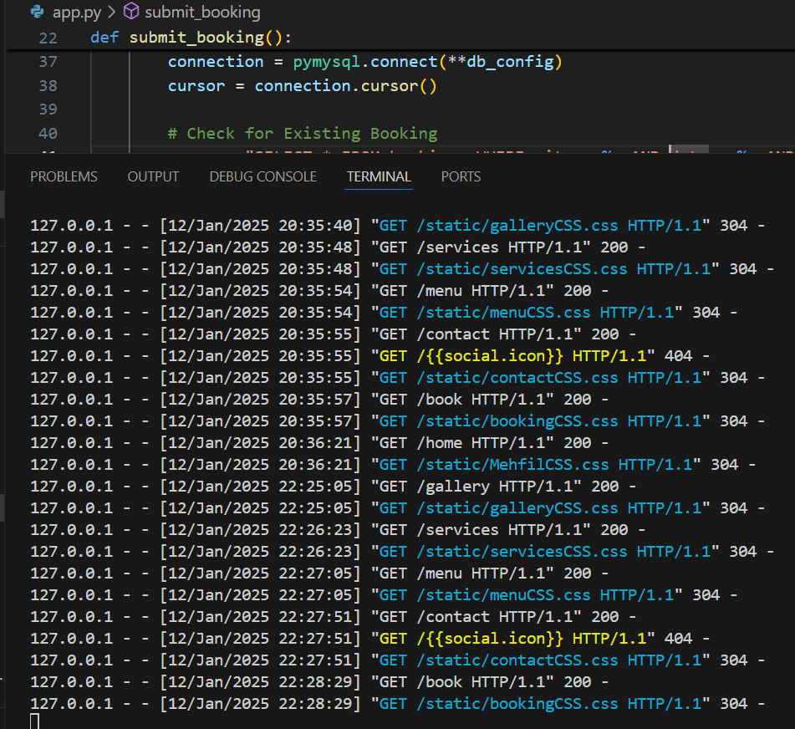

### **3.1.3. Database**

The database for the Mehfil website is powered by **SQL/MySQL**, an open-source relational database management system (RDBMS) widely used in web development. It ensures that the data entered by users—whether it be contact messages or event bookings—is securely stored and easily retrievable.

**MySQL Workbench** is used as a graphical interface to manage the database, creating and modifying schemas, tables, and entries. The database stores two main types of data:

1. **User Submissions**: Data from the contact and booking forms, including user details and event preferences.
2. **Event Data**: Details about events, venues, services, and menus, which users explore before booking.

#### **3.1.3.1. Workbench**

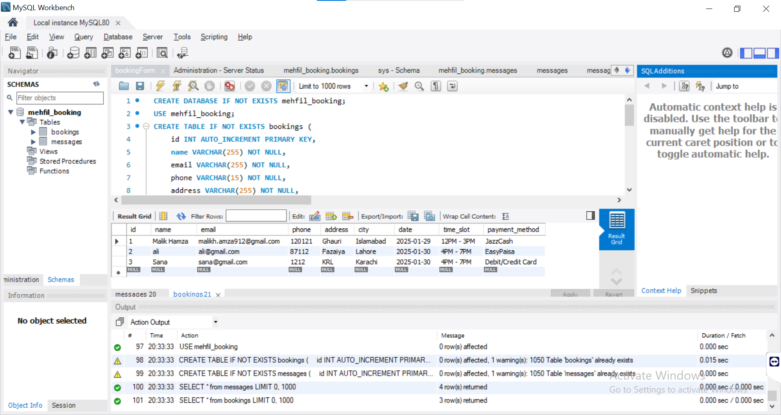

#### **3.1.3.2. Database Setup**

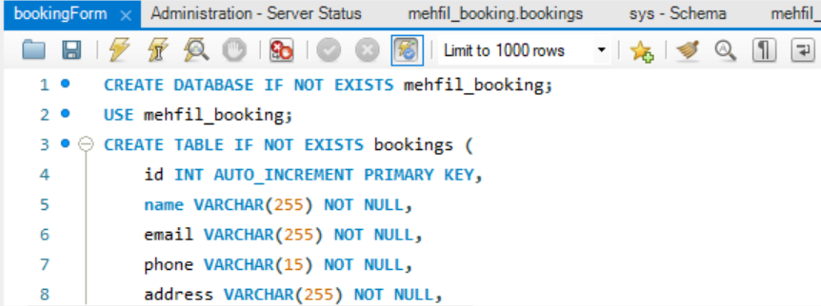

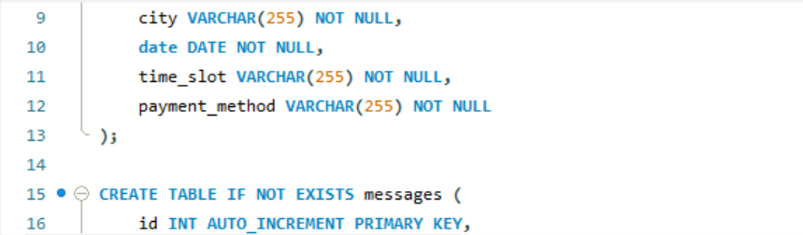

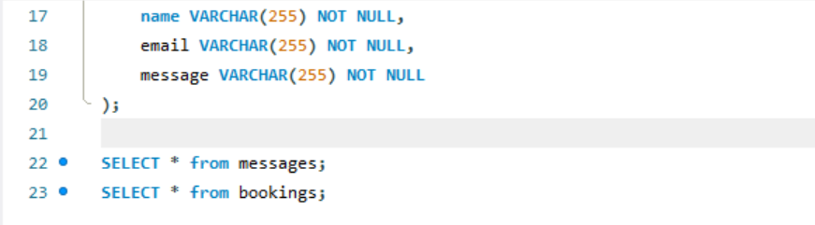

#### **3.1.3.3. Bookings Table**

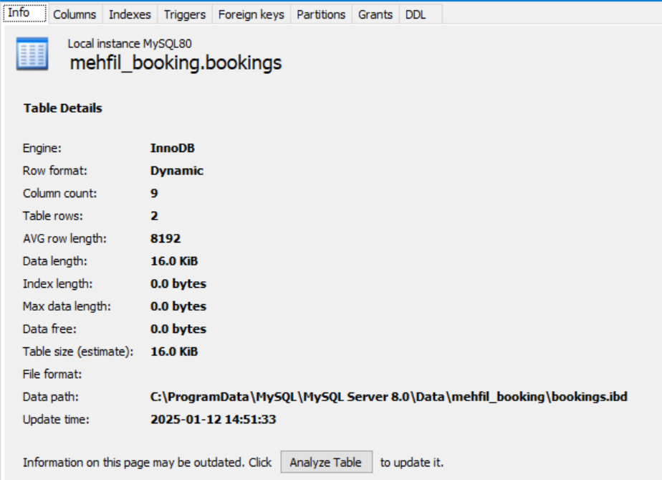

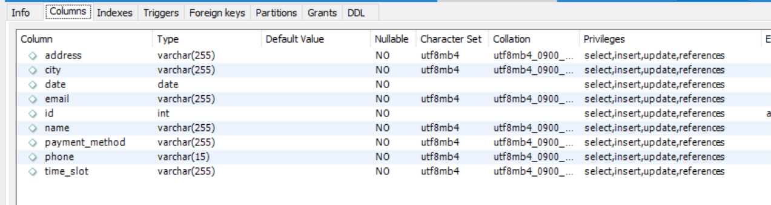

#### **3.1.3.4. Messages Table**

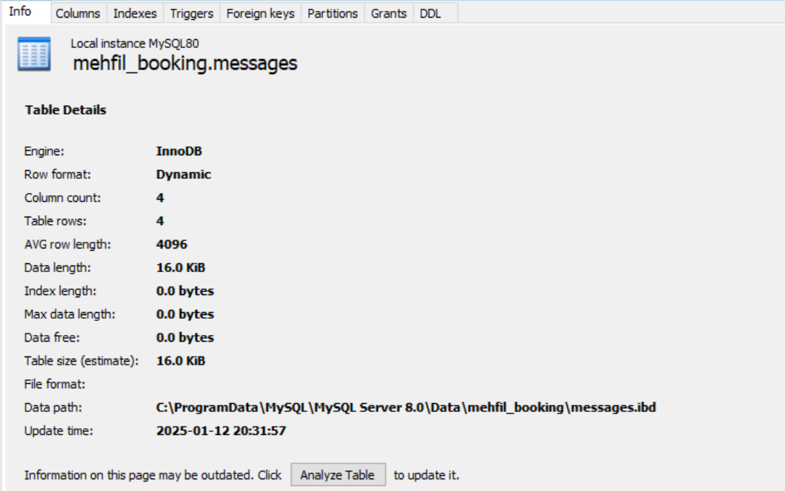

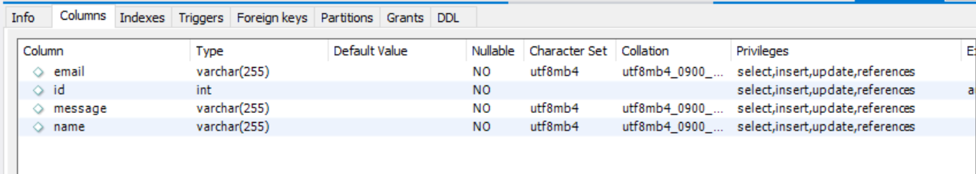

## **3.2. Scenarios**

The following two scenarios describe how the user interacts with the Mehfil website's forms:

### **3.2.1. Message Form in ‘contact.html’**

In the **Contact Us** section, the user fills out a form with details like name, email, and the message they want to send. Once the "Submit" button is clicked, the form data is sent to the backend via a **POST request**. The backend processes the message and stores it in the database, ensuring it reaches the appropriate recipient. After submission, the user receives a confirmation message, and the form resets for the next use.

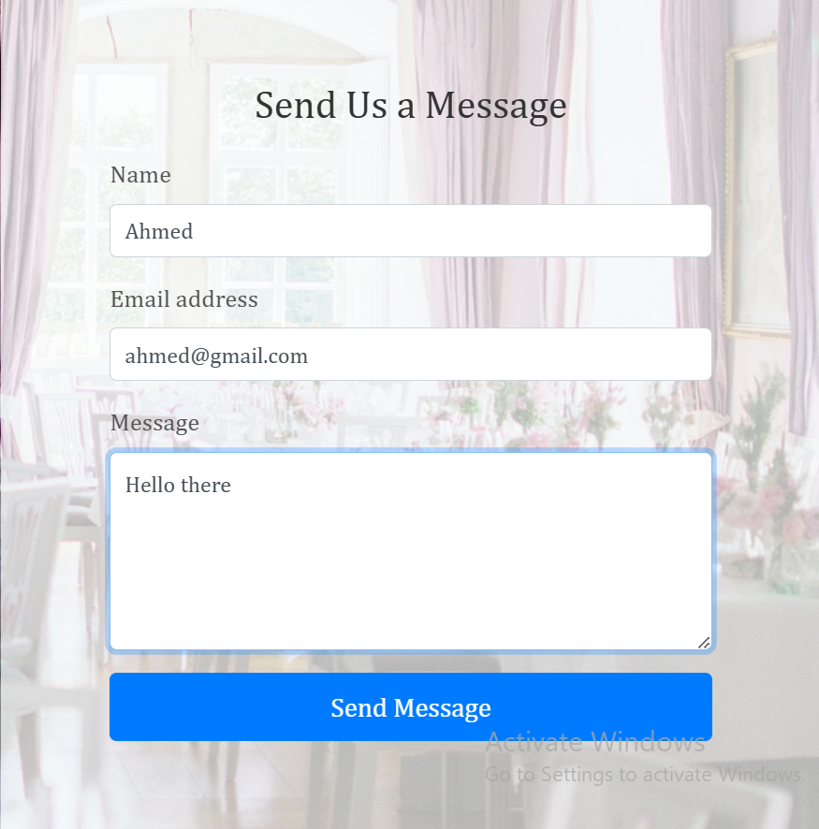

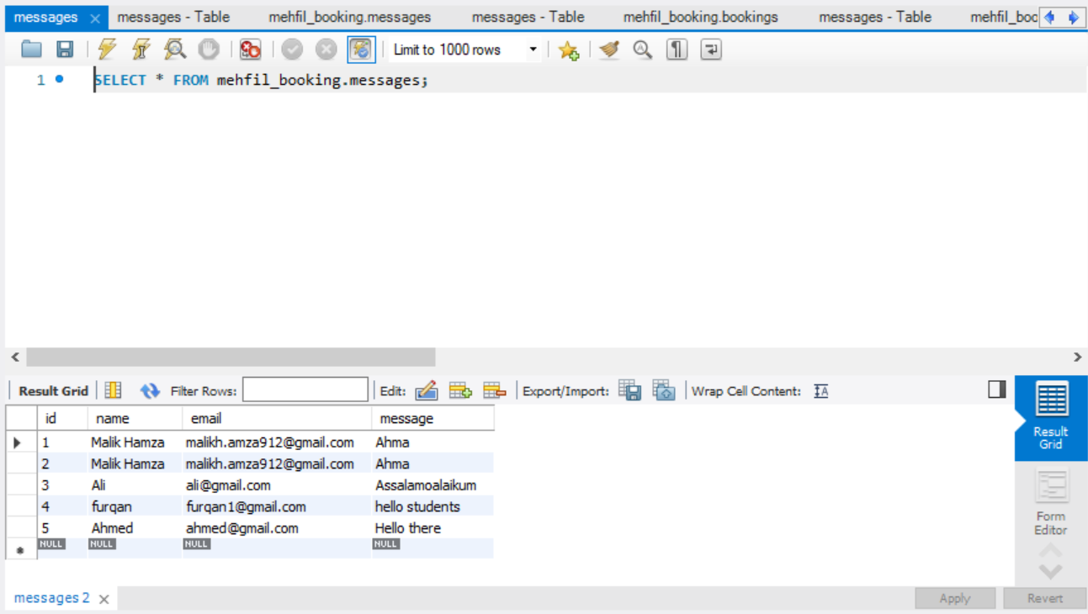

### **3.2.2. Event Booking Form in ‘booking.html’**

The **Event Booking** form allows users to book events by entering information such as event type, date, time, number of guests, and any additional preferences. Upon clicking the "Submit" button, the event data is sent to the backend for processing, where it is stored in the database. Users receive a confirmation email, and the form is reset to facilitate any future bookings. This process helps streamline event management for the venue.

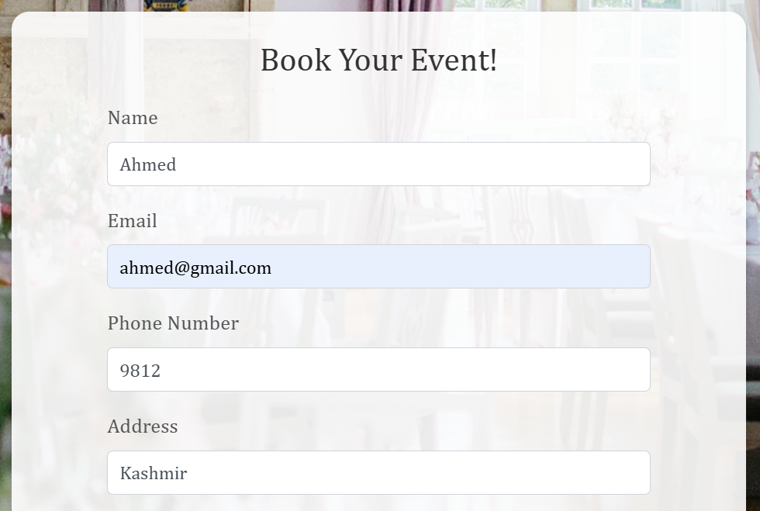

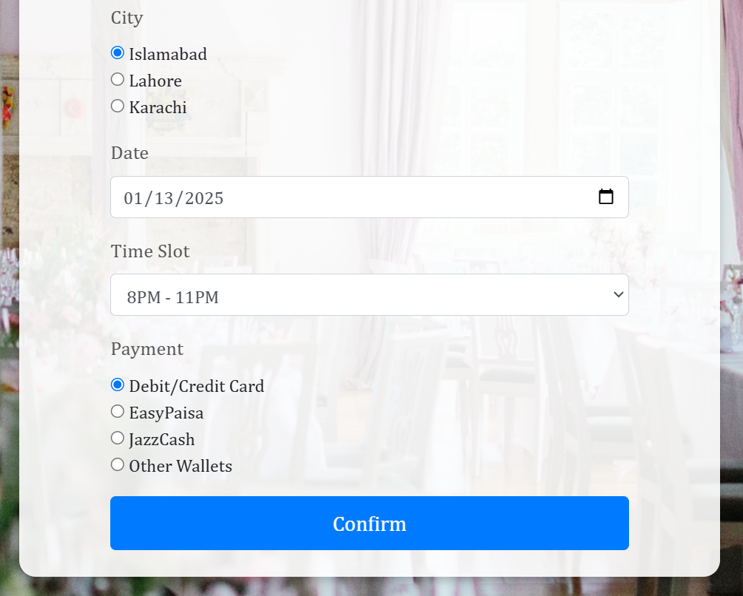

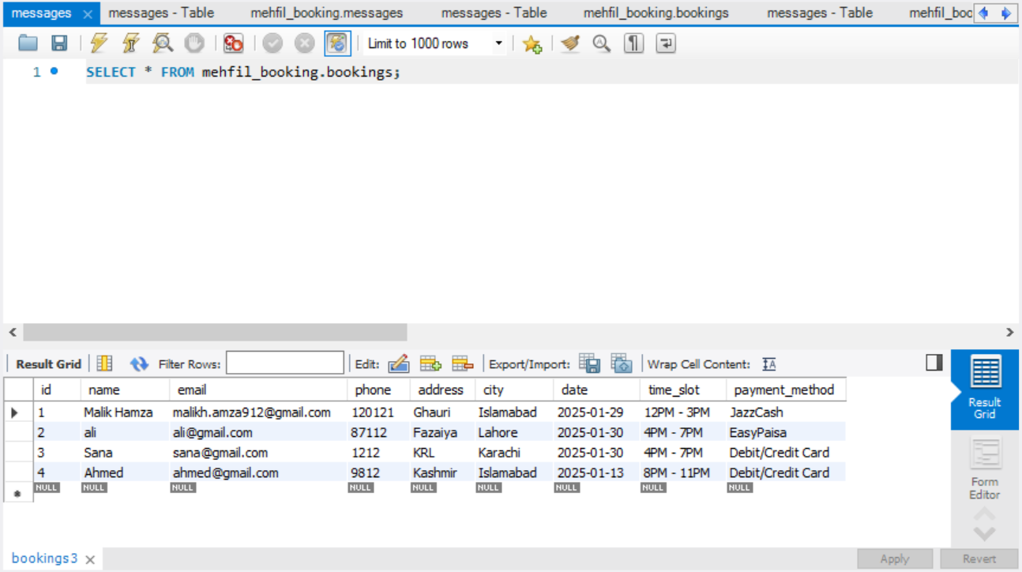

# **Chapter 4: Conclusion**

## **4.1. Conclusion**

The **Mehfil** event-booking website successfully achieves its goal of simplifying the event planning process by integrating essential features into a cohesive platform. It provides a clean and professional design while ensuring a seamless user experience. By combining effective use of front-end, back-end, and database technologies, Mehfil offers a powerful tool for both users and event venue managers.

## **4.1.1. Key Findings and Outcomes**

The Mehfil website delivers an intuitive user experience with its easy-to-navigate layout and functional event booking system. Users can now quickly explore services, view galleries, send messages, and book events, all in one place. The implementation of form submission with automatic reset significantly enhances user satisfaction.

## **4.1.2. Impact**

The Mehfil website's impact extends to both the business and the customer. For customers, it streamlines the event booking process and simplifies communication with the venue. For the business, the website automates many processes, reducing human error and providing a more professional and accessible interface for event management.

## **4.1.3. Recommendations or Future Improvements**

* **Integration with Payment Systems**: Implement a secure payment gateway to allow users to pay for bookings directly.
* **User Accounts**: Allow users to create accounts for tracking past events and booking preferences.
* **Advanced Filtering**: Introduce filters on the gallery and menu pages to make it easier for users to find exactly what they are looking for.